AATC_Monitor.py

This module allows Monitors to connect to the server and request information in order to display it or process it further. Monitors are similar to Users however with many permissions and features removed. Essentially they can only observe what is made public and what they have been granted permission to view by Users. The AATC_Monitor module is used by the AATC_Monitor_Viewer program to request details of Drones, Waypoints, Flights etc, however it would be possible to use the AATC_Monitor module to setup other programs such as providing a method to display the information on a webpage or to provide a way for clients to view information about other Users.

Import

The module imports 6 other modules, sockets , codecs ,ast and recvall are required to form a connection with the server. Sys is required to exit the program correctly and AATC_Crypto is required to encrypt the communications to the server and to validate the server.

MonitorInterface

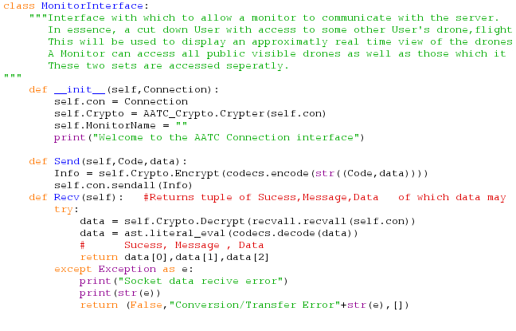
The MonitorInterface object is the main component of this module. It serves as an interface to simplify the communication between the server and the rest of the Monitor program. Instead of having to transfer a connection object between parts of a program and repeatedly have to catch exceptions, handle encryption , rewrite commands and other issues one only needs to create a single object and call the relevant methods of this object. If one required a command not yet implemented this method could be impemented by adding a new function to the class or by using the Send method of the class to directly send the message to the server.

The creation of a MonitorInterface instance requires one argument, a connection object to the server one wishes to use. This object will be stored as an attribute of the class and is used to send and receive messages from and to the server. A Crypter object is then created using this connection, forming the encryption parameters required to protect the session. MonitorName is set to the empty string. Finally the object prints “Welcome to the AATC Connection Interface” to signal that setup is complete.

The Send method takes a Command or Code and the parameters/data for that code. The information is then placed into a tuple in the form (code,data) which is then converted to a string and encoded in the byte string format required in order to encrypt the message and to send it. The encoded message is then encrypted using a crypter object and finally sent using the sendall method of the connection.

The Recv method waits for a message to be received using the recvall.recvall function. This function allows the socket to receive messages greater than the buffer size. The message is decrypted and decoded to form the original string version. Finally it is converted into a python expression (a valid tuple, rather than a string version of a tuple using the ast.literal_eval function. The data is then split into the three components of Sucess,Message and Data and returned to the caller function. Should the receiving fail e.g. due to a broken connection the function will catch the exception, output that a failure occurred and return a failure message to the caller.

Methods

The Monitor Interface has a number of methods to simplify the communication between the program and the server. These will be explained below and follow a similar pattern as below:
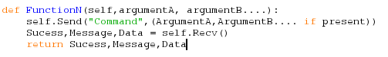
Each function takes 0 or more arguments, sends a message using the command and the arguments , recieves a response and returns the response. If the request does not require a data package to be returned there will not be a third return variable. Unless a method deiviates from this the basics of operation will not be explained.

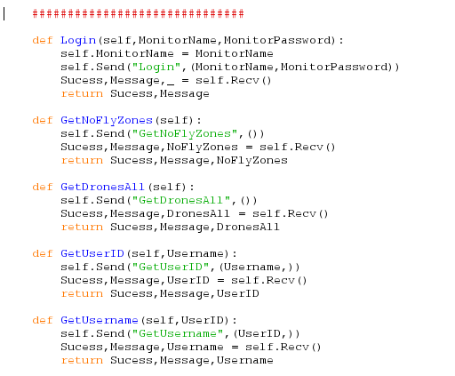
The Login method allows the Monitor to validate itself with the server. It requires a password and a Monitor name. The monitor name is unique to that monitor, only one monitor can have that name. The server will then return True or False depending if the login was successful or not , a relevant message and no data.

The GetNoFlyZones method obtains the data for each no fly zone. The message contains the table headers and the data contains a list of tuples of each row.

The GetDronesAll function obtains all publicly visible drones to the monitor with the message containing the table headers and the data containing a list of tuples for each drone.

The GetUserID function obtains the UserID for a given username and returns it to the monitor.

The GetUsername function obtains the username for a given UserID. This could be used to attach the username to a drone for ease of understanding which drones belong to which user.

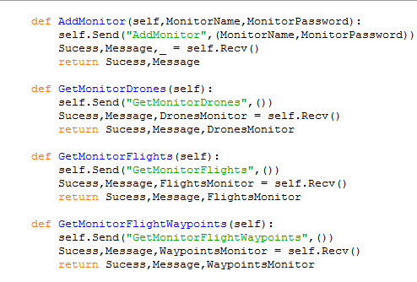
The AddMonitor function allows a new monitor to be added. This will setup a monitor with the name and password provided if the name has not already been taken.

The GetMonitorDrones function obtains all the drones for a monitor which have been made visible based on a monitor permission provided by the User of those drones. This feature could be used if a User only wants to provide access to the drone’s details to a limited set of monitors rather than make the entire system public.

GetMonitorFlights is similar to GetMonitorDrones whereby the function obtains the flights revealed by a monitor permission rather than drones.

GetMonitorFlights is similar , obtaining the FlightWaypoints provided by the permissions. All of these functions provide the headers in the message and the data in the form of a list of tuples.

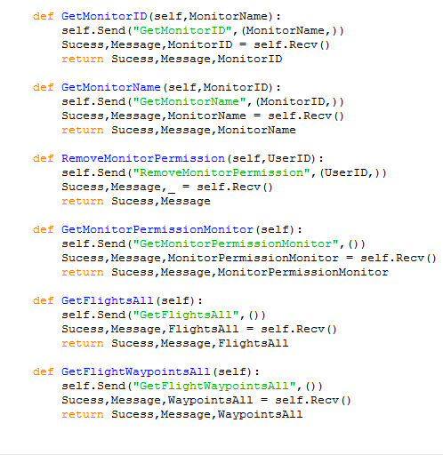
The function GetMonitorID obtains the Monitor ID for a given Monitor name or false if it does not exist. Similarly the GetMonitorName function obtains the MonitorName for a given monitor ID.

The RemoveMonitorPermission method removes the monitor permission for that UserID if present. This could be used if the monitor no longer wants to have access to those drones and cannot request the user to remove the permission prior to the expiry date.

The GetMonitorPermissionMonitor function obtains all the monitor permissions for that monitor. The message contains the headers and the data contains a list of tuples for each row.

The GetFlightsAll function obtains all the publicly visible flights. Similarly GetFlightWaypointsAll obtains all the publicly visible flight waypoints.

Miscellaneous
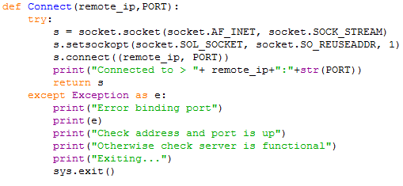
The Connect function attempts to connect to the remote IP on the specified port. In a try/except clause the program creates a socket and sets the socket to have a reusable address, meaning that if the socket closes unexpectedly i.e. due to a network failure the address can be connected to again before the TCP port times out. Finally the socket is connected to the address and the connection object is returned. If the connection fails then the program will print that the connection failed and close the program (closure may be removed).

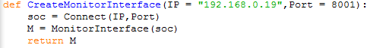
The CreateMonitorInterface function takes two optional arguments , IP a string and Port and integer, and connects to that address while creating a MonitorInterface instance using that connection and returns the interface to the caller.

